

*Where whispers of solace meet the quiet hum of empathy, offering a safe haven for hearts to find their voice*

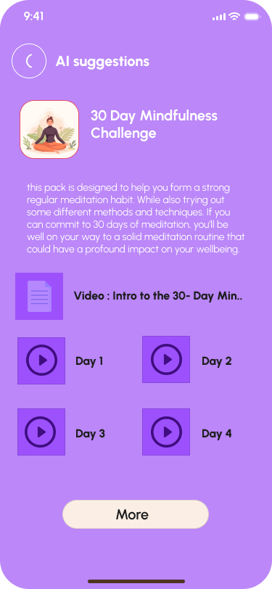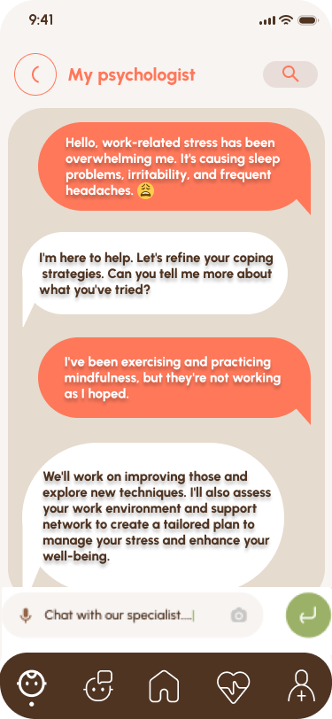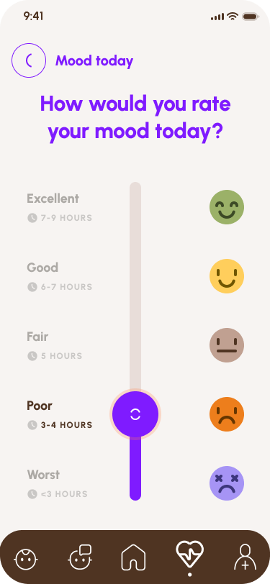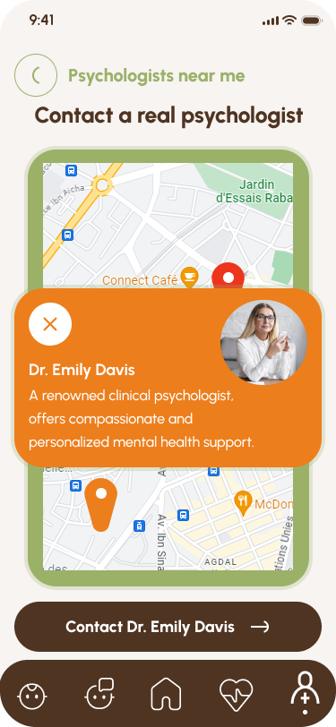

**Team members :**

Houda Larbi , OUAHIB Safaa,

Hiba BELLAFKIH, Saad HADICHE

**Abstract**

This project introduces an innovative AI-powered chatbot, acting as a virtual psychologist, to address the escalating gap in accessible mental health support. The chatbot aims to provide on-demand emotional support, guidance, and therapeutic interactions, offering a stigma-free and inclusive avenue for individuals. Traditional mental health services face limitations, including high costs and long wait times. Leveraging AI, the chatbot becomes a cost-effective, scalable solution, overcoming geographical barriers and ensuring timely assistance. The broader context explores AI's transformative potential across industries, highlighting its ethical considerations and challenges. The proposed AI chatbot exemplifies a promising step towards redefining mental health care accessibility while underscoring the responsible integration of AI in diverse sectors.

**Table of Contents**

1. Introduction

1.1 Introduction to AI-powered Therapy

1.2 Significance of Addressing Mental Health Challenges

1.3 Need for Cost-effective and Scalable Solutions

1.4 International Competition and Objectives

2. Literature Review

2.1 Exploration of AI in Mental Health Care

2.2 Review of Studies on AI-based Therapy and Chatbots

2.3 Global Need for Accessible Mental Health Solutions

3. Project Description

3.1 AI Chatbot for Therapy

3.2 Therapeutic Techniques and Counseling Strategies

3.3 Cost-effectiveness and Scalability of the Solution

3.4 Impact on Geographical Accessibility and Underserved Areas

4. Methodology

4.1 Training of the AI Chatbot in Therapeutic Techniques

4.2 Technology and Tools Used in Development

4.3 Ethical Considerations in AI-based Mental Health Interventions

5. Results

5.1 Preliminary Results and Outcomes

5.2 Positive Impact on Mental Health Care

6. Discussion

6.1 Implications of the Project for Affordable Mental Health Care

6.2 Challenges and Limitations of AI-powered Therapy

6.3 Comparison with Existing Solutions and Unique Contributions

6.4 Opportunities

7. Recommendations

8.1 Suggestions for Future Improvements or Extensions

8.2 Potential Collaborations with Other Institutions or Partners

8. Conclusion

**1. Introduction**

**1.1 Introduction to AI-powered Therapy:**

The introduction of AI-powered therapy marks a transformative shift in mental health care. Leveraging artificial intelligence, our project aims to create an innovative solution that provides accessible emotional support and therapeutic interactions. Unlike traditional approaches, this virtual psychologist utilizes advanced technologies to engage users in meaningful conversations, offering a novel avenue for mental health assistance.

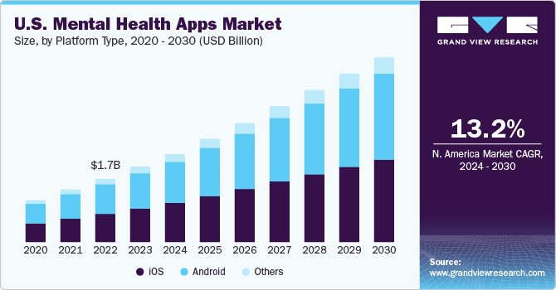

**1.2 Significance of Addressing Mental Health Challenges:**

The prevalence of mental health challenges necessitates innovative approaches for support and intervention. Our project recognises the critical significance of addressing these challenges in contemporary society. By deploying AI-powered therapy, we aim to bridge the gap in mental health care, offering timely and personalized assistance to individuals in need.

**1.3 Need for Cost-effective and Scalable Solutions:**

Traditional mental health services often face challenges related to cost and scalability. Our project responds to this need by proposing a cost-effective and scalable solution through AI-powered therapy. The chatbot's ability to reach a large number of users simultaneously ensures that mental health care becomes more affordable, accessible, and responsive to the increasing demand for services.

**1.4 International Competition and Objectives:**

Participating in the International Conference on Connected Innovation and Technology X.0 (ICCITX.0) and The Smart Healthcare International Conference (SHeIC) serves as a platform to underscore our commitment to advancing digital solutions in mental health care. The objectives of these competitions align with our vision of fostering innovation, collaboration, and addressing societal challenges. Through the presentation of our AI-powered therapy project, we aspire to contribute to the global conversation on enhancing mental health care through cutting-edge technology. Join us in shaping the future of healthcare and technology at these impactful conferences!

**2. Literature Review**

**2.1 Exploration of AI in Mental Health Care:**

The exploration of Artificial Intelligence (AI) in mental health care signifies a paradigm shift in the approach to diagnosis, treatment, and support. AI applications, such as machine learning algorithms, offer the potential to analyze vast datasets, aiding in the identification of patterns and early detection of mental health conditions. This section delves into the advancements and possibilities that AI introduces into the mental health landscape, emphasizing the transformative impact on the traditional models of care.

**2.2 Review of Studies on AI-based Therapy and Chatbots:**

A comprehensive review of studies focused on AI-based therapy and chatbots provides valuable insights into the effectiveness and potential challenges of these innovative interventions. This section critically examines existing literature, summarizing the methodologies, outcomes, and user experiences documented in studies related to AI-powered therapeutic approaches. By analyzing the successes and limitations, we aim to inform the development of our AI-powered chatbot for therapy and contribute to the evolving knowledge base in this domain.

**2.3 Global Need for Accessible Mental Health Solutions:**

The global need for accessible mental health solutions serves as a driving force behind the adoption of AI technologies. This section explores the increasing demand for mental health support worldwide, highlighting the limitations of current systems in meeting this demand. By leveraging AI, particularly through chatbots for therapy, our project aims

to address this pressing need, offering scalable, cost-effective, and widely accessible solutions. The literature review establishes the context for our project within the broader landscape of global mental health challenges and the role of AI in providing innovative solutions.

**3. Project Description**

**3.1 AI Chatbot for Therapy:**

MindCare aims to develop an AI-powered therapy chatbot proficient in therapeutic techniques and counseling strategies. This virtual companion engages users in text or voice conversations, offering a safe and confidential space for emotional support. By leveraging advanced AI technology, the chatbot provides personalized coping strategies and guidance.

**3.2 Therapeutic Techniques and Counseling Strategies:**

The project incorporates a diverse range of therapeutic techniques and counseling strategies into the AI chatbot. These strategies are designed to ensure that users receive meaningful and empathetic interactions, fostering emotional well-being and balance.

**3.3 Cost-effectiveness and Scalability of the Solution:**

MindCare addresses the challenges of cost and scalability in mental health services. The AI-powered therapy chatbot significantly reduces

costs, making mental health care more affordable. Its scalability ensures that a large number of users can access assistance simultaneously, meeting the increasing demand for services.

**3.4 Impact on Geographical Accessibility and Underserved Areas:**

By transcending geographical barriers, MindCare's teletherapy approach ensures that users in remote or underserved areas can access mental health care. This is a pivotal step in overcoming disparities in mental health support and reaching those who may face limited options for assistance.

**4. Methodology**

**4.1 Training of the AI Chatbot in Therapeutic Techniques:**

The AI chatbot undergoes comprehensive training in therapeutic techniques, ensuring it can provide meaningful and effective support to users. This involves leveraging machine learning algorithms to understand and respond to diverse emotional states.

**4.2 Technology and Tools Used in Development:**

The development of MindCare leverages state-of-the-art technologies, incorporating a blend of advanced AI algorithms, Natural Language Processing (NLP), Long Short-Term Memory (LSTM), and the powerful GPT-3.5 language model. This combination ensures a sophisticated and intelligent system capable of providing empathetic and contextually relevant interactions.

**Natural Language Processing (NLP):** MindCare harnesses the capabilities of NLP to understand and interpret user input, allowing for nuanced conversations and personalized responses. NLP facilitates the chatbot's ability to identify emotional states, providing a more tailored and effective therapeutic experience.

**Long Short-Term Memory (LSTM):** LSTM, a type of recurrent neural network (RNN), is employed to enhance the chatbot's ability to

understand and remember context over the course of a conversation. This technology enables MindCare to engage in more coherent and contextually aware interactions, contributing to the overall effectiveness of the therapeutic experience.

**GPT-3.5 Language Model:** MindCare integrates OpenAI's GPT-3.5, a cutting-edge language model, to enrich the quality of conversations and responses. GPT-3.5 brings a vast language understanding and generation capability to the chatbot, allowing it to provide nuanced insights, coping strategies, and therapeutic interventions.

**Secure Data Storage:** To prioritize user confidentiality and data security, MindCare implements secure data storage solutions. Advanced encryption protocols and secure server infrastructure ensure that user data remains protected, fostering trust and compliance with privacy standards.

**User Interface Design:** MindCare places emphasis on creating a user-friendly interface that prioritizes accessibility and confidentiality. The

design incorporates intuitive navigation, ensuring users can easily engage with the chatbot. Moreover, the interface is crafted to maintain a safe and confidential space, fostering a sense of trust and comfort for users seeking emotional support.

**4.3 Ethical Considerations in AI-based Mental Health Interventions:**

MindCare places a strong emphasis on ethical considerations in AI-based mental health interventions. Privacy, data security, and user consent are paramount, and the project adheres to ethical guidelines to ensure the well-being and trust of users.

**5. Results**

**5.1 Preliminary Results and Outcomes:**

MindCare presents any preliminary results or outcomes from the development and testing phase, showcasing the effectiveness of the AI chatbot in providing valuable emotional support.

**5.2 Positive Impact on Mental Health Care:**

This section delves into the potential positive impact of MindCare on mental health care, shedding light on how the project actively addresses pressing challenges and contributes to the enhancement of emotional well-being. MindCare's impact is framed within both short-term and long-term perspectives, acknowledging its immediate effects and its broader vision for transformative change.

**Short-Term Impact:** MindCare is strategically designed to provide immediate emotional support, aiming to reduce the stigma associated with seeking help for mental health concerns. In the short term, the project anticipates a positive impact on users' well-being, offering a reliable and accessible platform for seeking assistance and fostering a sense of connection and understanding.

**Short-Term Vision:** Looking ahead in the short term, MindCare envisions becoming a trusted and widely accessible emotional support platform. The vision includes expanding its user base and actively promoting destigmatization surrounding mental health. By doing so, MindCare aims to contribute to a cultural shift in attitudes towards seeking emotional support.

**Long-Term Impact:** MindCare's long-term impact extends beyond individual well-being to envision a global change in mental health care. The project aspires to empower millions of individuals, fostering emotionally fulfilling lives through continuous innovation and research. The long-term impact is rooted in MindCare's commitment to being a catalyst for transformative change in how mental health is approached and addressed on a global scale.

**Long-Term Vision:** In alignment with its long-term impact, MindCare's vision is ambitious. The project aspires to lead a global mental health transformation, envisioning the creation of a comprehensive and destigmatized ecosystem for emotional well-being. MindCare aims to make a lasting and meaningful impact on millions of lives worldwide, demonstrating the potential for sustained positive change in the field of mental health care.

**6. Discussion**

**6.1 Implications of the Project for Affordable Mental Health Care:**

This section examines how MindCare contributes to affordable and accessible mental health care. By leveraging AI-powered therapy, the project addresses financial barriers, ensures geographical accessibility through teletherapy, and plays a crucial role in the broader initiative to tackle mental health challenges. MindCare's innovative approach not only enhances individual well-being but also contributes to creating a more inclusive and equitable mental health care environment, aligning with the overarching goal of addressing societal mental health challenges.

**6.2 Challenges and Limitations of AI-powered Therapy:**

1. **Understanding Nuances:**
   * *Challenge:* AI may struggle with the nuanced aspects of human emotions.
   * *Mitigation:* Continuous refinement of algorithms based on research and user feedback.
2. **Ethical Considerations:**
   * *Challenge:* Concerns about user privacy, data security, and ethical use.
   * *Mitigation:* Robust privacy measures, ethical guidelines adherence, and transparent communication.
3. **Cultural Sensitivity:**
   * *Challenge:* Difficulty addressing diverse cultural contexts.
   * *Mitigation:* AI model cultural awareness training, collaboration for diverse content, and regular updates for inclusivity.
4. **User Engagement and Trust:**
   * *Challenge:* Ensuring sustained user engagement and building trust.
   * *Mitigation:* User-friendly interfaces, active feedback incorporation, and awareness campaigns.
5. **Integration with Traditional Approaches:**
   * *Challenge:* Harmonizing AI with traditional therapies.
   * *Mitigation:* Collaboration with professionals, hybrid care models, and facilitating communication.
6. **Regulatory Frameworks:**
   * *Challenge:* Navigating complex regulations.
   * *Mitigation:* Engagement with legal experts, staying updated, and proactive participation in policy discussions.

**6.3 Comparison with Existing Solutions and Unique Contributions:**

MindCare distinguishes itself from existing mental health care apps through its innovative AI-powered therapy, offering a unique blend of personalized support, advanced emotional analysis, and live video consultations with licensed therapists. While some mental health apps provide basic resources, MindCare stands out by prioritizing immediate emotional support, reducing stigma, and fostering a safe and confidential space for users. The app's emphasis on accessibility, affordability, and its comprehensive approach to well-being sets it apart from others, contributing to a transformative shift in the landscape of mental health care applications.

1. **Headspace:**

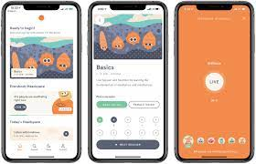

* + **Focus:** Guided meditation and mindfulness.
  + **Strengths:** Stress reduction, sleep improvement.
  + **Weaknesses:** Limited in addressing immediate emotional support.

1. **Talkspace:**

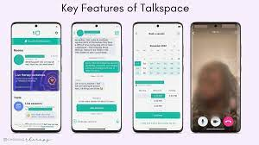

* + **Focus:** Online therapy with licensed therapists.
  + **Strengths:** Professional support through text, video, and voice.
  + **Weaknesses:** May lack advanced AI features for emotional analysis.

1. **Calm:**

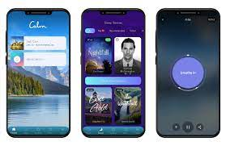

* + **Focus:** Relaxation and sleep aid through meditation.
  + **Strengths:** Soothing content and guided sessions.
  + **Weaknesses:** Limited in addressing specific emotional states.

1. **BetterHelp:**

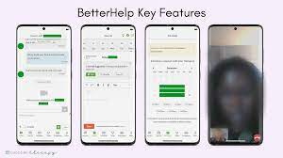

* + **Focus:** Professional online counseling.
  + **Strengths:** Access to licensed therapists.
  + **Weaknesses:** Potential limitations in immediate support and AI features.

1. **Wysa:**

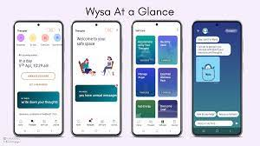

* + **Focus:** AI-driven mental health support.
  + **Strengths:** Chatbot for emotional well-being.
  + **Weaknesses:** May lack the comprehensive features of live video consultations.

**6.4 Opportunities:**

* **Market Demand:** The global mental health services market, with 264 million patients, indicates substantial demand.
* **User Base Potential:** Approximately 158.4 million individuals are accustomed to using mobile apps, presenting an opportunity for MindCare's adoption.
* **Competitive Landscape:** With only 20,000 competing wellbeing apps, there is room for MindCare to establish itself as a prominent player.

**7. Recommendations**

**8.1 Suggestions for Future Improvements or Extensions:**

* **Diversify Revenue Streams:**

Explore additional monetization avenues, such as partnerships and sponsorships. Implement a freemium model to attract and retain users.

* **User Retention and Satisfaction:**

Continuously enhance the app to keep users engaged and satisfied. Actively gather user feedback and make necessary improvements.

* **Strategic Partnerships and Collaborations:**

Strengthen existing partnerships and build new ones with healthcare providers, universities, and mental health organizations. Deepen research collaborations to gain insights for improvement and better user outcomes.

**8.2 Potential Collaborations with Other Institutions or Partners:**

Exploring avenues for collaboration with other institutions or partners to further strengthen the impact of MindCare.

Potential Partners:

* **Entraide Nationale:** A Moroccan nonprofit organization focusing on social assistance and family support, offering assistance in reaching marginalized populations who may benefit from MindCare's services.
* **Alwane Association:** A local mental health association, identified as a potential collaborator for insights and collaboration on content development to ensure cultural sensitivity and relevance.
* **Université Hassan II Casablanca:** Collaboration proposed with local universities for research and data analysis, with the possibility of engaging students in mental health-related research initiatives.
* **Casablanca Hub:** A startup incubator and accelerator in Morocco that could provide valuable mentorship, resources, and support for the development and scaling of MindCare.

National Partners in Morocco:

* **Wysa:** An Indian mental health tech startup specializing in AI-driven chatbot therapy. Collaboration suggested for AI

enhancements and potential integration of their AI chatbot features into MindCare.

* **Talkspace:** A U.S.-based telehealth startup. Exploration recommended for potential integrations or partnerships, particularly for live video consultations with therapists and expanding MindCare's service offerings.
* **Koko:** A Canadian AI-powered social support platform. Collaboration proposed for AI-driven features and community building within MindCare to provide additional support.
* **Moodmission:** An Australian app that provides personalized mental health micro-missions. Suggested collaboration on content development and integration of mission-based support within MindCare.

**8. Conclusion**

MindCare emerges as a pioneering AI-powered therapy, addressing mental health challenges by providing affordable, accessible, and confidential emotional support. The project's key findings and contributions underscore its transformative impact on mental health care, while highlighting the broader potential of AI chatbots in reshaping global mental health practices. The call to action encourages ongoing research and implementation, positioning MindCare as a catalyst for future advancements in leveraging technology to enhance mental well-being on a global scale.